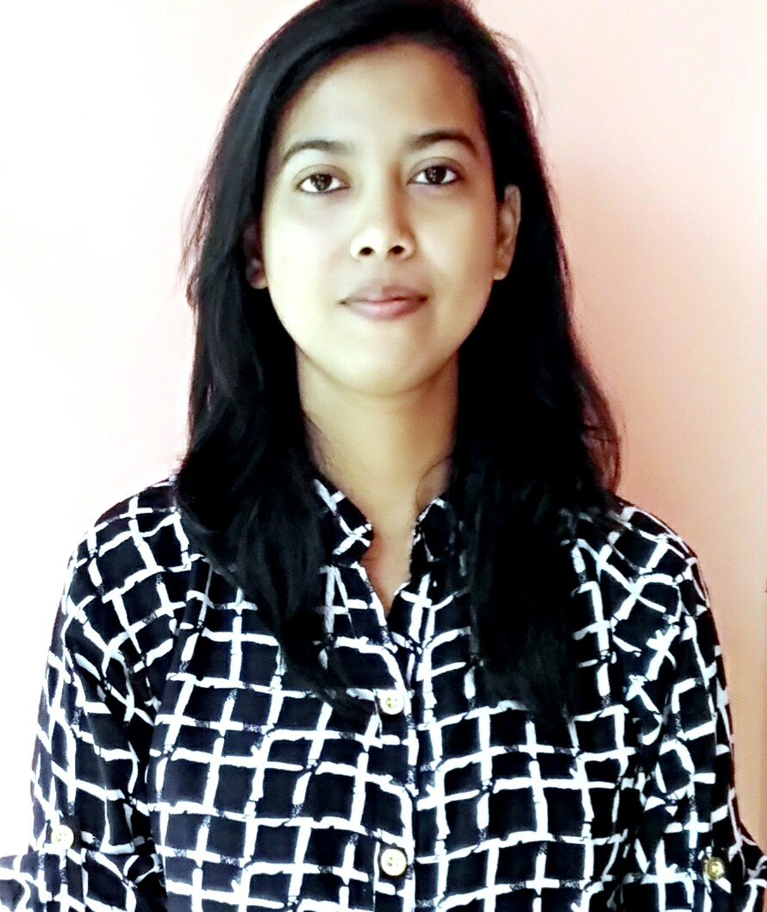  Students Name: Shiny Purkayastha  Basic Qualification: M.Sc Zoology  Professional Qualification:  Advanced Post Graduate Diploma in Clinical Research, Clinical Data Management and SAS  E-mail : shinyp8@gmail.com  Mobile (+91-7399510013/9864530759  Home (03842-265196  Present Address:  House No-22, Jagadish Basu Lane, Vivekananda Road, District-Cachar, Silchar-788007, Assam.  Personal Data  Date of Birth : 25/01/1991  Sex : Female  Nationality : Indian  Marital Status: Single  Languages Known: English, Hindi, Bengali  Permanent Address:  House No-22, Jagadish Basu Lane, Vivekananda Road, District-Cachar, Silchar-788007, Assam. | CURRICULUM VITAE  Career Objective:  To evolve into a professional individual in the organization, to obtain a position in an intellectually motivating environment and to use my skills for the benefit and success of the organization, with the willingness to learn and enhance my knowledge.  Clinical research knowledge:  - Excellent knowledge of ICH-GCP & Schedule Y  - Principles of Pharmacology and Drug Discovery  - Roles & Responsibilities of Key Stakeholders  - Preparation and Planning for Clinical trials  - Essential Documentation in Clinical Research & Regulatory Submissions  - Clinical trials Project Planning & Management  - Study Start Up Process  - Clinical Monitoring Essentials  - Compliance , Auditing & Quality Control in Clinical Research  - Clinical Data Management, Biostatistics, Analysis & Reporting  Clinical data management knowledge:Data and Databases  - Data Management and the Data Management Plan  - Data Entry  - Transcribing data  - Identifying and Managing Discrepancies  - Cleaning Data  - Data Tracking the CRFs  - Study setup  - Design Considerations  - Electronic Data Capture  - Coding  - Database Closure  - Managing Laboratory Data  - Collecting Adverse Event Data  - Creating Reports  - Data Transfers  - Data Acquisition  - Audit Trail  - QA in Clinical Data Management  SAS programming knowledge:  - Data Step Processing  - Raw Data  - Starting with SAS Data sets  - Working with Numeric Variables  - Creating Subsets of Observations  - Working with grouped or sorted observations
Professional Qualification:
Academic Credentials | University | Aggregate
Advanced Post Graduate Diploma in Clinical Research, Clinical Data Management and SAS | Cliniminds, Guwahati | Result awaited
Basic Qualification  M.Sc Zoology | Assam University (2014) | 76.4
B.Sc Zoology | Gurucharan College  (Assam University) (2012) | 64
HS (Higher secondary) | Gurucharan college(2009) | 59
HSLC(High school leaving certificate) | South Point School (2007) | 75

  - Previous Job Profile:

Derby Royal Aqua (Packaged Drinking Water), Govind Enclave Pvt.Ltd., Silchar , Cachar, Assam

Designation - Microbiologist

Job Duration- 2014-2015

Job Profile- Handling and Preservation of Water samples; Detection and Enumeration of Micro-organisms in sample water following microbiological tests; Taking care of hygiene conditions as per INDIAN STANDARDS
Practical Hands-on:
Protocol/CRF/ICF designing
Oracle clinical software program
Technical Skills:
- Basic Knowledge of operating systems ( Windows XP, Vista, Windows 7), tally ERP9
- M.S. Office, M.S. Excel, M.S. PPT. 2003,2007,2010.

Strength:
- Excellent written & verbal communication skills.
- Possess good presentation skills.
- Have a flexible approach to changing situations.
- Flexible and Quick learner, Ability to lead, and dedication towards task at hand.
- Ability to work in team environment.

.

Declaration:
I hereby declare that the information given above is genuine to the best of my knowledge and if you give an opportunity to work in your organization, I will put my best efforts.

Place: silchar
(Shiny Purkayastha)

